**Initial Project Proposal**

**Project Title:** Task Scheduler and Tracker

**Project Description:**The Task Scheduler and Tracker is a system designed to facilitate task management for individuals or teams. It allows users to create, modify, and delete tasks, set reminders, and automate task-related activities using Bash scripts.

**Team Member & Roles:**

Jared Pierce - Database Design/Program Design

Tammie Illg - Bash Scripting/Program Design

Aysia Clay- C programmer/Program Design

**Target Audience:** Individuals or teams seeking a tool for personal or collaborative task management.

**Scope Of The Project:**

* Develop a task scheduler with functionalities for adding, modifying, and deleting tasks.
* Utilize C programming for core logic and MySQL for storing task details.
* Implement Bash scripts for task automation, such as sending reminders, marking tasks as completed and tracking of time spent on tasks.

**1st Sprint Deliverable(Found At the Bottom Of the Doc):**

* **Flow Chart:** [Group 6.draw i](https://drive.google.com/file/d/1HEkej73wYkQLCKPdcjUvzMlbhTzActI9/view?usp=sharing) (click the link)
* **Sample Pseudo Code:** [**Pseudo Code**](https://docs.google.com/document/d/1XLCRvgiwQL8bleugB9NrtQTnVmyIAxIECEG1yUDu-4s/edit) **(click the link)**
* **List Of Functions:**

**checkUserProfile():**

Function to check if the user already has a profile.

**createUserProfile():**

Function to guide the user through creating a new profile.

**isUsernameUnique(username):**

Function to check if the provided username is unique in the database.

**saveProfileToDatabase(username, password, dob, email, phoneNumber):**

Function to insert the user profile data into the database.

**listAllTasks(userID):**

Function to retrieve and list all tasks currently stored in the database.

**createTaskForm():**

Function to guide the user through creating a new task.

**saveTaskToDatabase(taskName, taskCategory, taskDescription, taskDuration):**

Function to insert the task data into the database.

**updateTaskForm():**

Function to guide the user through updating an existing task.

**updateTaskInDatabase(taskID, updatedTaskData):**

Function to update the task data in the database.

**deleteTaskByID(taskID):**

Function to delete a task from the database based on its ID.

**readUserProfile():**

Function to retrieve and display user profile information.

**updateUserProfileForm():**

Function to guide the user through updating their profile information.

**updateUserProfileInDatabase(updatedUserData):**

Function to update user profile information in the database.

**manageReminders():**

Function to manage reminders, such as changing timing or settings.

**clearForm():**

Function to clear any form data if the user chooses not to save.

**exitProgram():**

Function to gracefully exit the program.

* **Database Diagram**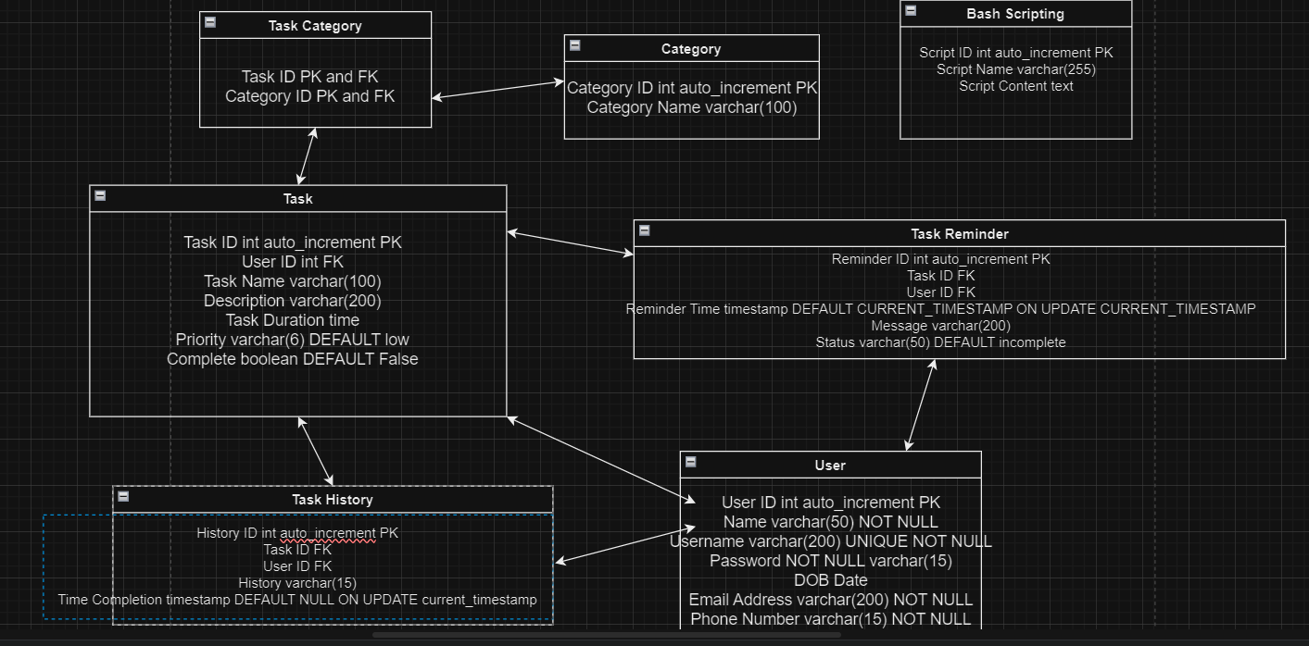
* **Database Data**

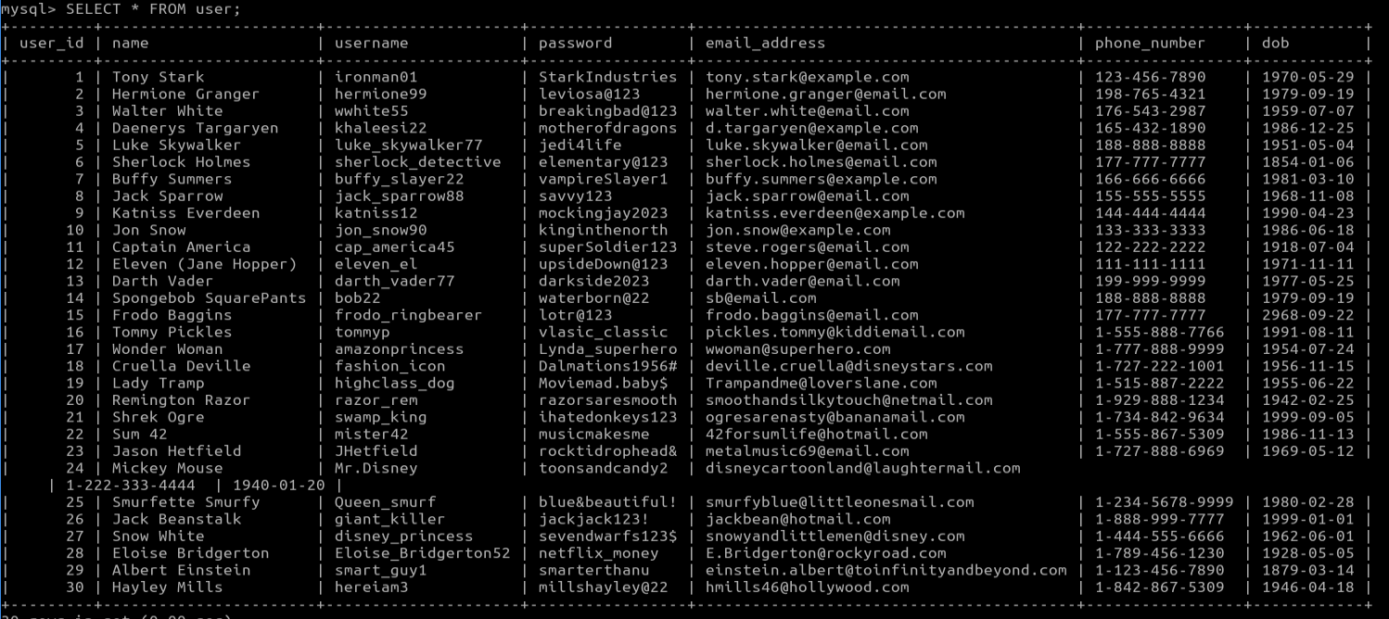

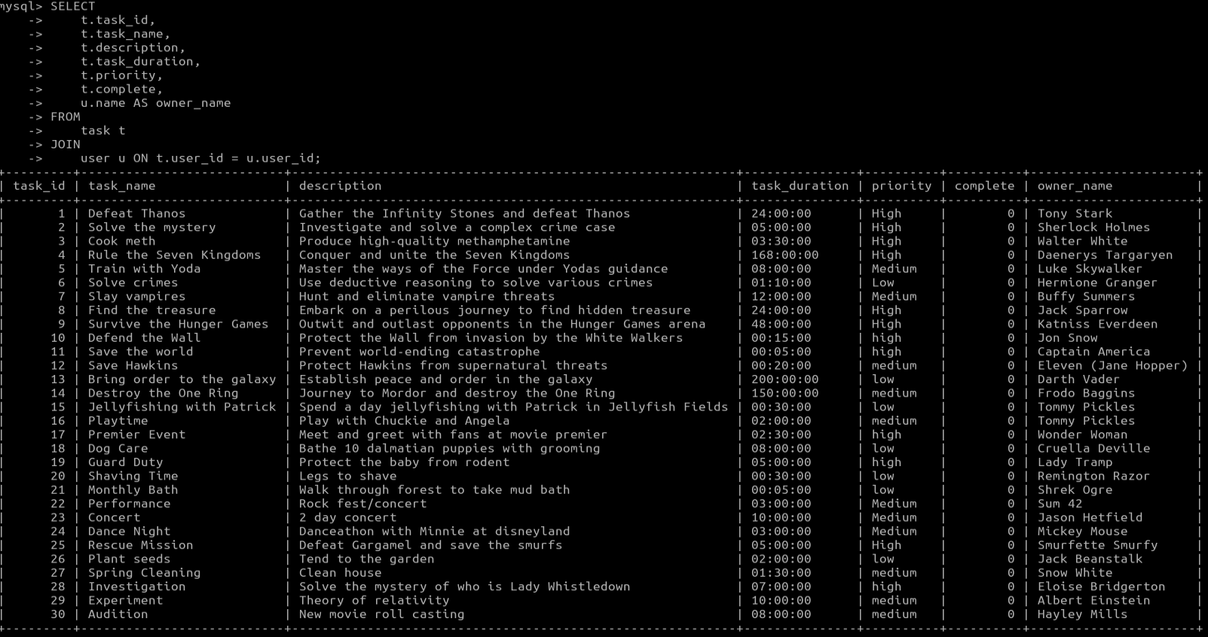

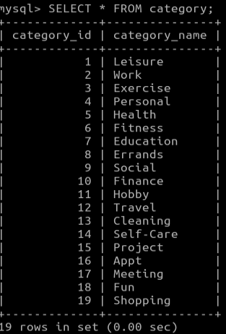

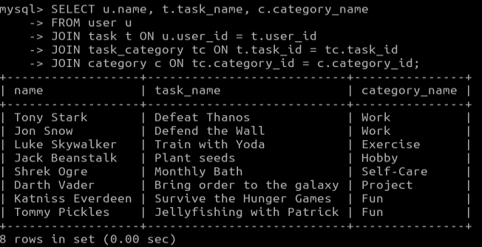

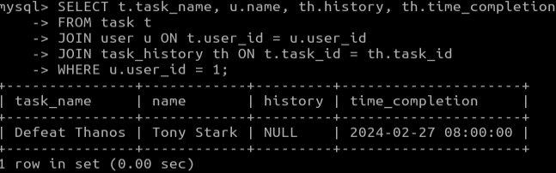

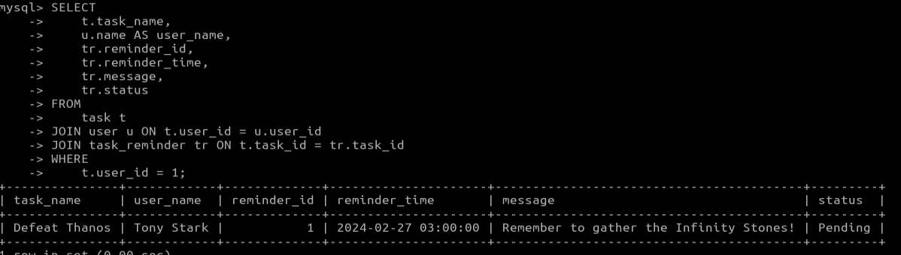

**Updating/Setting a category name for an existing task based on the task name and category names in system:**

**Before:** 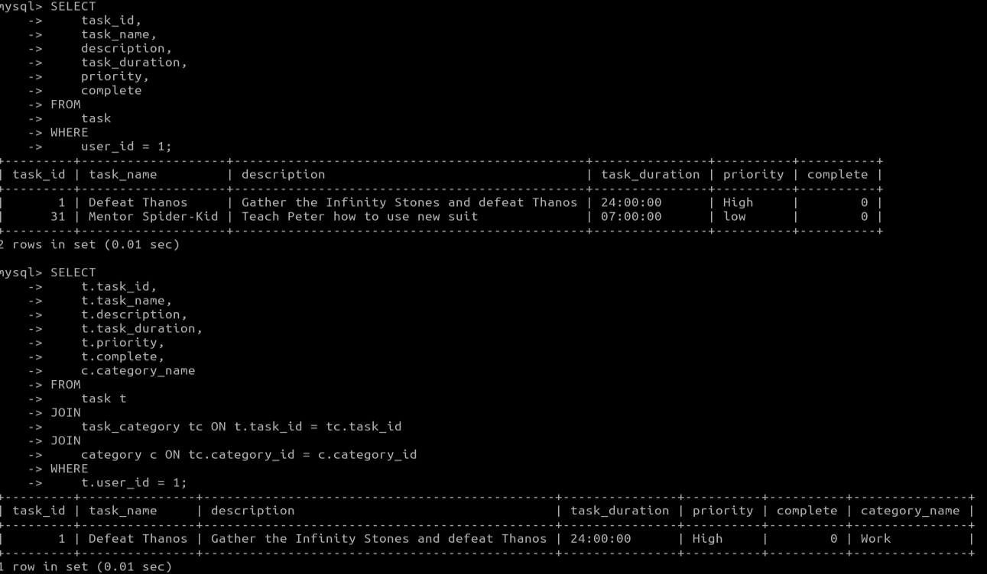

**After:**

